Proposed car parking area & entrance for AA Dog Training site at Grange Rd Netley Abbey
BLOCK PLAN
AREA 90m x 90m
SCALE 1:500 on A4
CENTRE COORDINATES: 446731, 110076

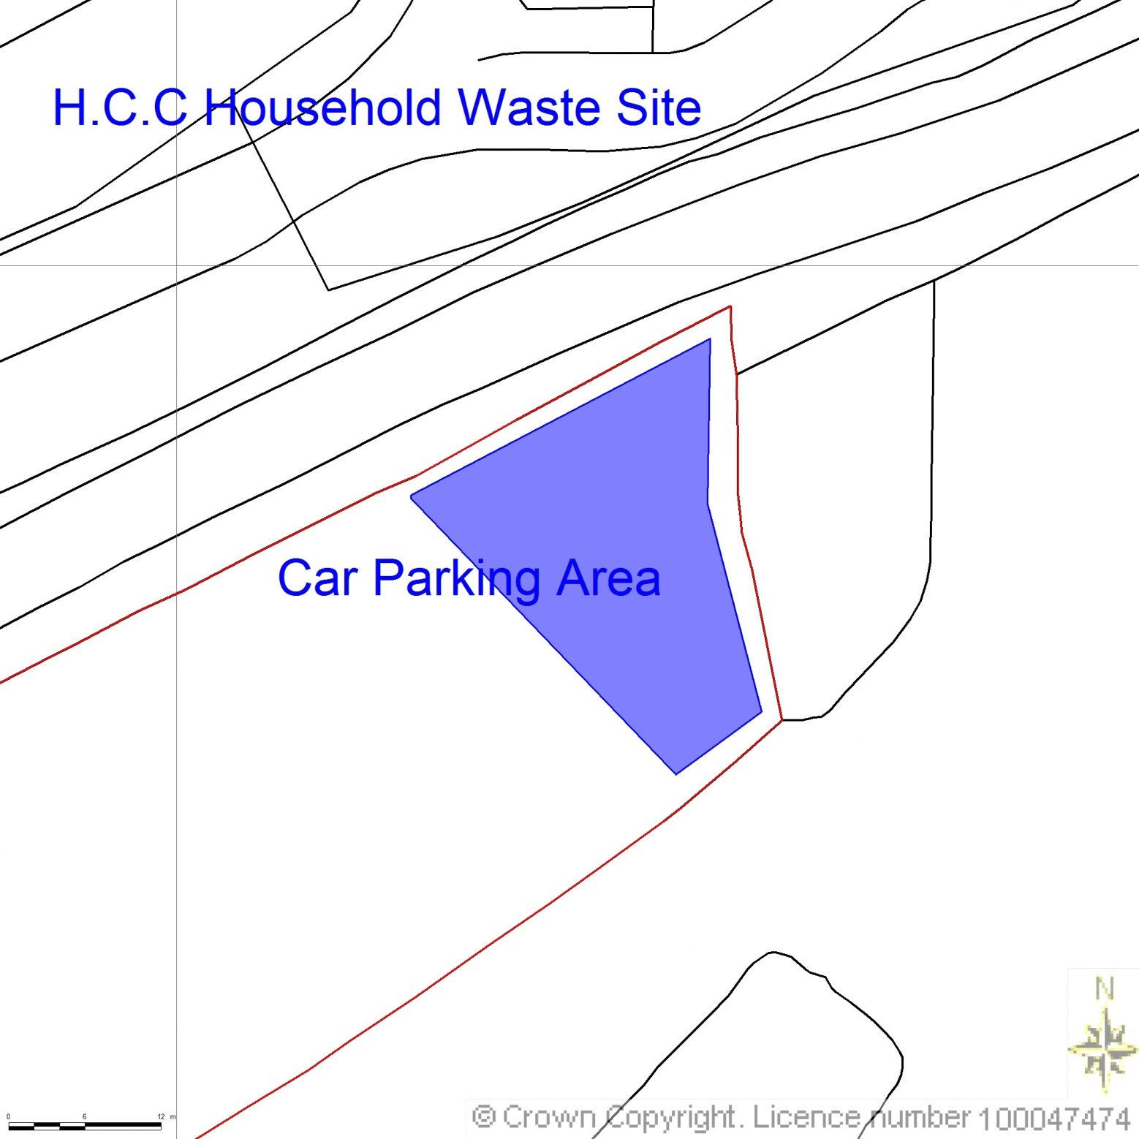

Grange Rd

Splayed Entrance 3.6m
Boundary of Mixed Shrub & Trees

Overspill
Parking

