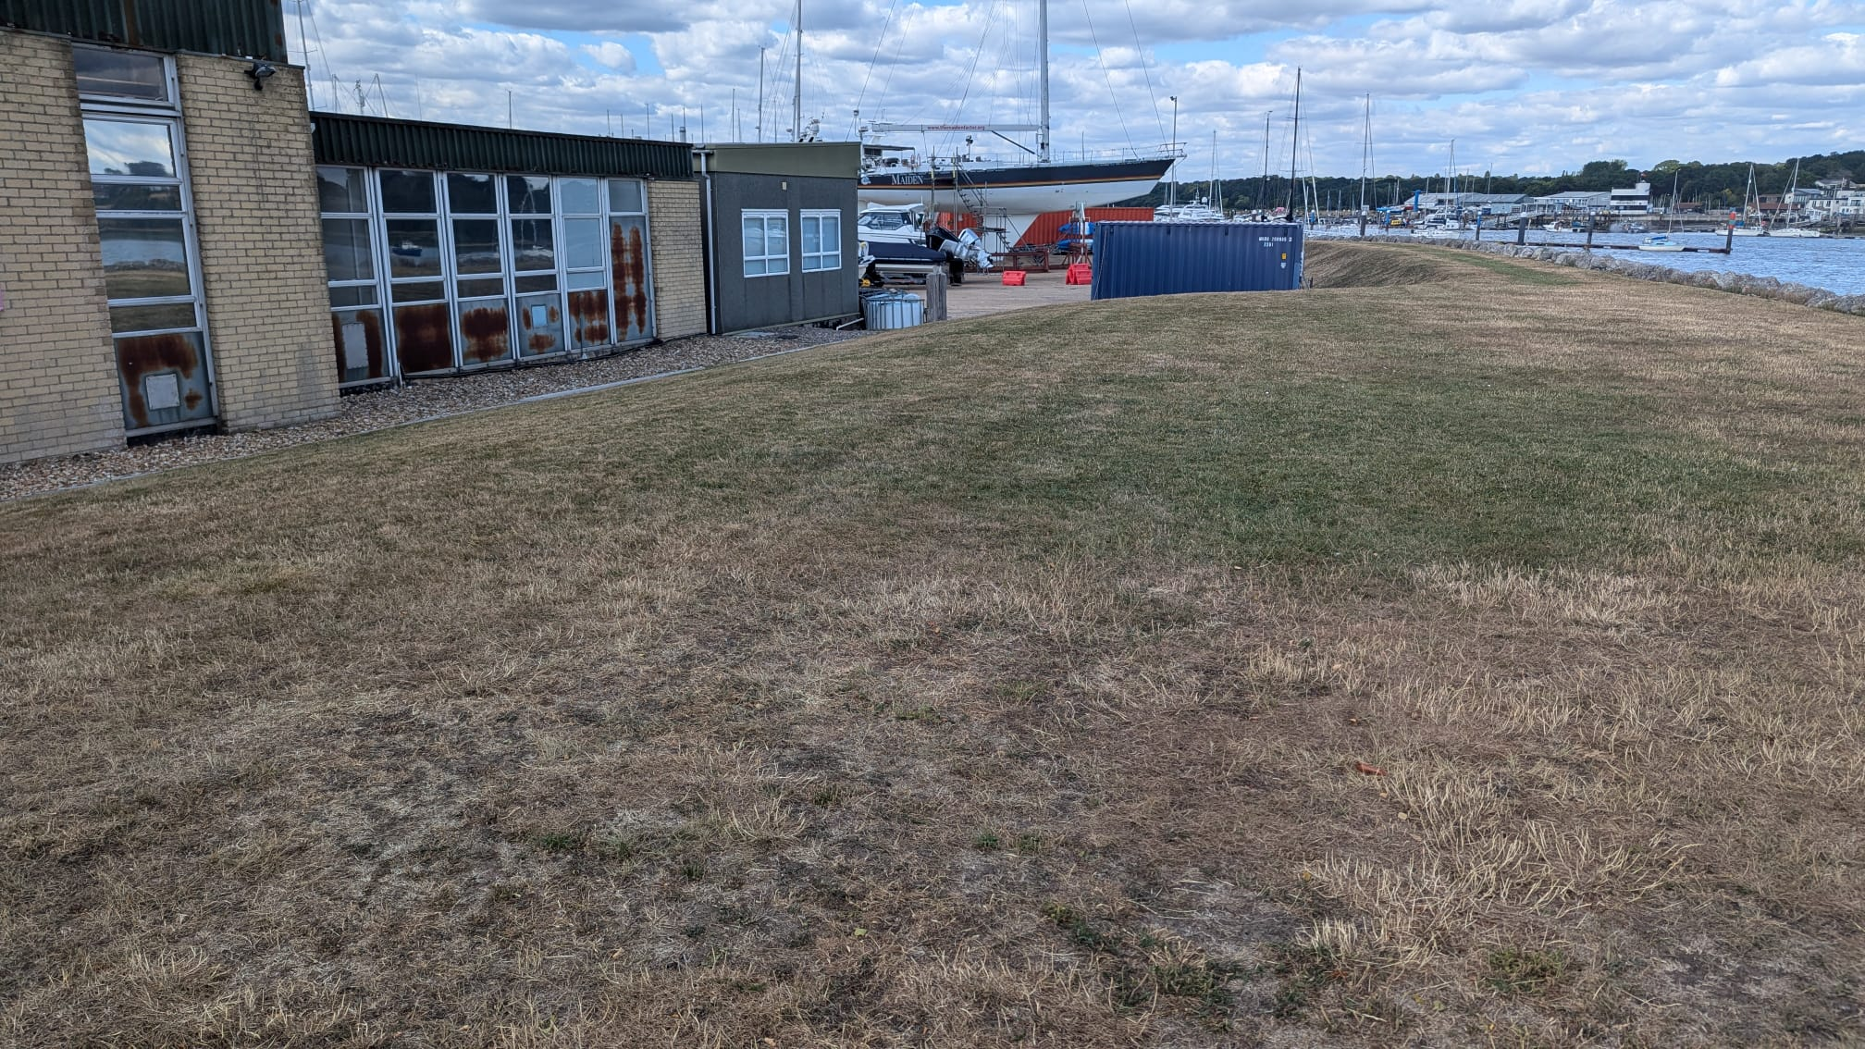

Habitat Management and Monitoring Plan
Site Name: | Hamble Point
Date: | 23/01/2026
Version: | 1.0

Author:


Client:

Template Document User Guide
Please delete this guidance page upon completion.
Template User Guide
You can use the Habitat Management and Monitoring Plan Template (HMMPT) for on-site or off-site biodiversity net gain projects. It is suitable for sites of varying sizes and complexity, from small and simple to large and complex. It provides a series of tables, figures and textboxes. Complete these to demonstrate how habitat creation, enhancement and management will be undertaken. Not every box will be relevant to every project. Omit those considered not relevant to your project, applying professional judgement.

Companion Document
The Companion Document contains templates for each broad habitat type used in the statutory biodiversity metric. It also assists authors in completing the ‘Environmental Information’, ‘Creation, Enhancement and Management’ and ‘Monitoring’ sections. To tailor the plan for your site, insert the relevant standardised forms from the Companion Document into your main HMMPT.

Site Baseline and Environmental Information
Considering the site's characteristics, choose the relevant baseline site conditions and background environmental information to include in your management plan. This is essential in informing the design of your project and shows the reviewer you have considered these in the proposals for the site. These include the proposed habitat creation and enhancement. Also, what is appropriate to include or exclude, or to point the reviewer to relevant information that has provided elsewhere as part of the application. Use the ‘Baseline and Environmental Checklist PB-T01’ to record relevant references, or reasons if not included.

HMMP Checklist (separate document)
This checklist is a summary of the HMMP Template headings. Author and reviewer can scan the list to check which HMMP details to include, or that have been included, in the submitted plan. You can also list and link to relevant supporting documents to accompany the templated details if required. This helps avoid duplication of information. The reviewer can then easily check which information to expect to see in the HMMPT and which to review in an alternative linked document.
Formatting
The HMMPT format is intended as a guide. The Template uses standard Microsoft Word formatting that has not be locked for editing. You can therefore adjust it to tailor your HMMP as required for the specific site and according to your preferences. For example, you can change text box sizes to reduce blank space in the template.
There are opportunities to provide and reference additional photographs and plans as separate appendices if required. Provide the reference number of the appropriate appendix, or location if included in a separate report, using the appropriate box within the template.
Text in grey is provided as a prompt. Replace grey text with your own words. Remember to change to black text then delete any remaining grey ‘prompt’ text.
You can delete blue text as this is for guidance purposes only.
Each text box in this HMMPT has a unique ID to assist reviewers. Do not change the reference code of any Boxes or Tables.
Supporting documents
- HMMPT Companion Document
- Statutory Biodiversity Metric tools and guides
- Biodiversity Net Gain Guidance
Using the Companion Document
The Companion Document includes additional boxes and tables that must be manually copied into this template using the copy-and-paste function. To streamline the copying and pasting process, you can minimise the heading by selecting the arrow on the left. Once the arrow is selected, when you copy, you will also copy any accompanying boxes or tables.
It is the author's responsibility to decide what additional information is appropriate to include.
Template published by Natural England.
We acknowledge the significant input from the HMMPT user-testers and production on Natural England’s behalf by FPCR Environment and Design.

Contents
1. Project Background 4
Summary of Management Plan 4
Site Boundary Plan PB-F01 6
Site Context Plan PB-F02 7
Phasing strategy 8
Roles and Responsibilities 8
Land Use Summary 10
Site Context Photos PB-F03 10
Site Baseline, Environmental Information and Associated Impacts Checklist PB-T01 12
Baseline and Environmental Information 13
Designated Sites (BI-T01) 13
Protected and Notable Species (BI-T02) 14
Flood Risk Zones 15
Flood Risk Zone Plan (EI-F07) 17
2. Planned Management Activities 18
Principles Informed by Design Stage 18
Habitat and Condition Targets PM-T01 19
Habitat Retention 20
Habitat Retention Plan PM-F01 20
Creation, Enhancement and Management Targets and Prescriptions 21
Individual Trees 21
Creation, Enhancement and Management Summary (CS-T01) 21
Individual Trees 23
Creation, Enhancement and Management Methods (CS-T02) 23
Species Lists (CS-T03) 25
Other Supporting Information 25
What Does Success Look Like? (CS-F01) 25
Urban SuDS 26
Creation, Enhancement and Management Summary (SC-T01) 26
Urban SuDS 28
Creation, Enhancement and Management Detailed Methods (SC-T02) 28
SuDS Species Lists (SC-T03) 29
Other Supporting Information 29
What Does Success Look Like? (SC-F01) 30
Habitat Creation and Management – Risk Register and Remedial Measures PM-T02 32
3. Monitoring Schedule 33
Monitoring Strategy 33
Monitoring Methods and Intervals MS-T01 33
Monitoring Reports 34
Adaptive Management 35

Version Control
The version control is used for updates to the content. Record the initial version and further version control details in this table each time the management plan is altered throughout the management and monitoring period.
Version | Issue Status | Prepared by / Date | Approved by / Date
01 | 01 | Izaak Reader 05/01/2026 | William Coulet 09/01/2026

Document Details
Provide ownership, copyright and licensing information within this table.
Authorship Details
Exo Environmental Ltd.
The Enterprise Centre
University of East Anglia
Norwich Research Park
Norwich, NR4 7TJ
Norfolk

Use this box to provide relevant details of document ownership by the author, such as company address, copyright or map licence information.

Project Background
Summarise the key aspects of your management plan in this section. Table PB-B01 can be extended to suit the specific needs of individual projects.
Site Overview PB-B01
Project type | on-site
Development Name and Address | Hamble Point Marina
BNG Project Name and Address
Author Organisation | Exo Environmental Ltd.
Landowner | Marina Developments Limited (MDL)
Land Manager | n/a
Responsible person/organisation for creating or enhancing the habitat | Marina Developments Limited (MDL)
Period covered by this management plan | 35 BNG period, starting at the completion of the onsite intervention  Start/end point of 30+ year period and 5-year update (including phasing if applicable)
Planning authority | Hampshire County Council (Eastleigh Borough Council)
Planning reference (if applicable) | F/25/100291
BNG register reference (if applicable) | N/A
Central OS grid reference | SU 48584 05744
Metric revision/title | Statutory Biodiversity Metric from January 2024
Are any Irreplaceable Habitats present onsite | Yes: ☐ No: ☒

Summary of Management Plan
Habitats to be Retained, Created and Enhanced PB-B02
The 0.59ha site is primarily comprised of concrete hard standing. Also, within the project redline, are 2 mature sea buckthorn trees and 3 maturing silver birch trees oversailing a 0.13ha patch of modified grassland . The 2 medium sea buckthorn trees (trees 2 &3) are to be removed as part of the project, whilst the 3 silver birch trees will be retained. Also retained are a small patch of ornamental introduced shrub, and a medium nonnative, ornamental tree.
SuDS planters will be installed as part of the drainage management. In accordance with the SuDS Manual, the total combined surface area of the planters is to be 26m2. Exact placement is yet to be determined, subject to detailed design considerations.
The sea buckthorn trees which are to be removed, will be replaced with 0.13ha of trees. This will be made up of 8 medium trees, or 32 small trees (or a combination of both e.g. 4 medium and 16 small trees). It is recommended that sea buckthorn be used for at least some of the trees which are planted, as a direct replacement for the trees that are lost. The trees will be planted in the retained modified grass parcel with exact locations to be confirmed during landscaping. It is anticipated that the trees will achieve good condition, given they will be in the same context as the trees which are to be removed. Once planted, they will need to be guaranteed for 35 years. They must be managed to form trees rather than shrubby thickets. Occasional reporting will be required with photographic evidence that the trees are surviving in good condition. Any trees that die during this period, should be replaced. Habitat maintenance must be outlined in a simple Habitat Management and Monitoring Plan (HMMP), as a planning condition.
Provide a high-level summary of the habitats to be retained, created and enhanced as part of this HMMP.
Timescales for Actions PB-B03
The habitat creation and enhancement will take place during the project construction and will be complete when the project is finished. There will be no delay in habitat unit creation. Monitoring will initially take place annually in August for the first 5 years, reducing to every 5 years for the remainder of the 35-year monitoring period. Monitoring reports will be submitted every 5 years.
Monitoring Requirements PB-B04
Monitoring methods include photos and species lists which will be used to complete metric condition assessments to ensure target conditions are maintained.
Required Consents and Licences PB-B05
N/A

List the relevant consents and licences required as part of this HMMP.

Funding PB-B06
Funding for the HMMP will be provided by the landowner-MDL.

Provide an overview of how funding has been secured to deliver the HMMP.

Legal Agreement PB-B07
To be enshrined in an LPA compliance planning condition.
This agreement will bind the landowner to deliver the required habitat enhancements and monitoring over a minimum period of 35 years, in accordance with the approved BNG Plan and HMMP.
The LPA will review reports in line with this HMMP and make recommendations as required.
Provide an overview of any legal agreements that secure the delivery of the HMMP.

Site Boundary Plan PB-F01
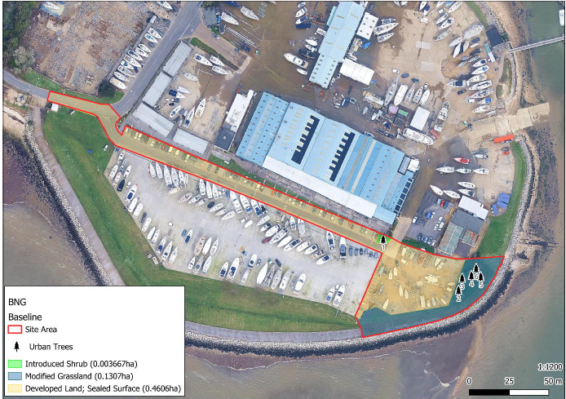

Site Context Plan PB-F02
This plan should show the location of the site, including the LPA, boundary, national character area, and any relevant landscape scale policy or guidance information.
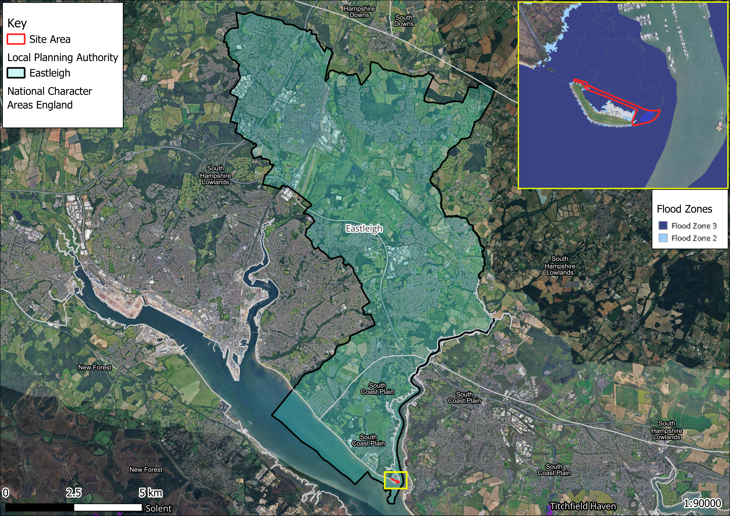

Phasing strategy
Will the proposed work measures be delivered in phases? PB-B08 | Yes: ☐ No: ☒
Provide details of how the project and any habitat creation and enhancement works and their management will be phased.
Include details of how this will be tracked and monitored to achieve the BNG targets on the ground.
State if this management plan covers a single phase or if it is a site wide management plan.
If being provided for a single phase, provide a reference to a document that provides information on the overarching management plan for all phases.

Roles and Responsibilities
Provide details of the responsible persons and organisation(s) for delivering this management plan.

Ecologist or Other Professional Responsible for HMMP PB-B09
Name or Initials |  | Wiliam Coulet
Organisation |  | Exo Environmental Ltd.
Responsibility | Start Date: | 05/01/2026 | End Date: | Upon planning submission
The author is only involved up to the point planning permission submission.
The author has completed the following for this submission:
BNG statement
Statutory BNG metric
Statutory BNG condition assessment
BNG self-assessment checklist
BNG mapping (baseline and post development)
Statement of Competency
The author completed the assessment with the assistance of the Biodiversity Net Gain Tool.
Complies with the definition of a “competent person” provided by HM Government BSI Standards (BS 8683: 2021), and in supplementary material provided by Natural England.

Landowner or Land Manager PB-B10
Name or Initials |  | Steve Russell
Organisation |  | MDL Marinas
Responsibility | Start Date: | Upon planning permission approval | End Date: | Completion of 35-year HMMP
The landowner, MDL, will retain legal responsibility for delivering and maintaining the Biodiversity Net Gain habitats in accordance with the approved HMMP and BNG Plan for a minimum of 35 years. The landowner may appoint third parties, such as qualified ecological consultants or land managers, to undertake habitat creation, management, and monitoring tasks on their behalf. However, overall accountability for compliance with the BNG obligations will remain with the landowner.
Summarise the relevant responsibilities of the landowner (or land manager if appropriate) in the production and, or, implementation of this HMMP
Statement of Competency
An appropriate implementation body (e.g. ecological consultant or habitat contractor) will be appointed to fulfil the implementation of this HMMP.
Demonstrate management and monitoring competency and, or, relevant site knowledge and skills through relevant training, qualifications or experience, or a combination of these.

Management Organisation(s) Responsible for Implementing the HMMP PB-B11
Name or Initials |  | N/A  Add N/A if works being completed by the landowner or land manager
Organisation
Responsibility | Start Date: |  | End Date:
Summarise the relevant responsibilities of the Management Organisation(s) in the production and, or, implementation of this HMMP.
Statement of Competency
Demonstrate the knowledge, skills and, or, experience to manage the habitats to achieve the BNG requirements, through relevant training, qualifications, experience, or combination of these.

LPA or Responsible Body for Reviewing HMMP PB-B12
Name or Initials |  | N/A
Organisation |  | Hampshire County Council (Eastleigh Borough Council)
Responsibility | Start Date: | Upon planning permission approval | End Date: | Completion of 35 year HMMP
To be enshrined in an LPA compliance planning condition.
This agreement will bind the landowner to deliver the required habitat enhancements and monitoring over a minimum period of 35 years, in accordance with the approved BNG Plan and HMMP.
The LPA will review reports in line with this HMMP and make recommendations as required.

Land Use Summary
Overview of Baseline Site Use PB-B13
The 0.59ha site is primarily comprised of concrete hard standing .Also within the project redline, are 2 mature sea buckthorn trees and 3 maturing silver birch trees oversailing a 0.13ha patch of modified grassland. The 2 medium sea buckthorn trees (trees 2 &3) are to be removed as part of the project, whilst the 3 silver birch trees will be retained. Also retained are a small patch of ornamental introduced shrub, and a medium nonnative, ornamental tree.
Provide a concise overview of the current site use including a summary of the habitats present, any specific management operations currently in effect and any other land uses.
Provide the context for the management activities to assist the reviewer in understanding the changes proposed.

Overview of Proposed Site Use PB-B14
This project constitutes the ‘’Erection of new restaurant (use class E(b)) and associated works at Hamble Point Marina’’. The total area under consideration is 0.59 hectares, (grid reference SY 99858 91289).
SuDS planters will be installed as part of the drainage management. In accordance with the SuDS Manual, the total combined surface area of the planters is to be 26m2. Exact placement is yet to be determined, subject to detailed design considerations.
The sea buckthorn trees which are to be removed, will be replaced with 0.13ha of trees. This will be made up of 8 medium trees, or 32 small trees (or a combination of both e.g. 4 medium and 16 small trees). It is recommended that sea buckthorn be used for at least some of the trees which are planted, as a direct replacement for the trees that are lost. The trees will be planted in the retained modified grass parcel with exact locations to be confirmed during landscaping. It is anticipated that the trees will achieve good condition, given they will be in the same context as the trees which are to be removed. Once planted, they will need to be guaranteed for 35 years. They must be managed to form trees rather than shrubby thickets. Occasional reporting will be required with photographic evidence that the trees are surviving in good condition. Any trees that die during this period, should be replaced. Habitat maintenance must be outlined in a simple Habitat Management and Monitoring Plan (HMMP), as a planning condition.

Summarise the site's anticipated uses, including proposed habitats, management regimes and intended land uses.

Site Context Photos PB-F03
Please include two overview photographs of the site in its current form here. Include additional photographs in an appendix if needed. Tick if additional photographs are provided in the Appendices ☐ Reference: Click or tap here to enter text.
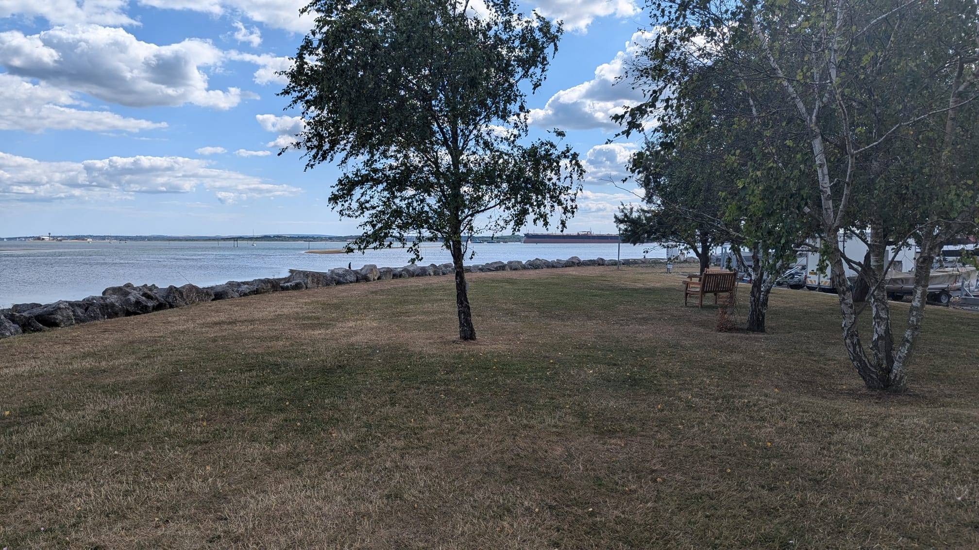

Site Baseline, Environmental Information and Associated Impacts Checklist PB-T01
Consider the Baseline and Environmental Information listed below. These are likely to be appropriate factors informing your proposals and project design. They can provide the reviewer with important contextual information for the management prescriptions provided later in this document. Use your professional judgement to determine which factors are relevant to your specific project.
Please use the check box to indicate which are included in your plan. For any not included, provide brief reasons why the factor is not relevant to your project using your professional judgement. Where this information is provided elsewhere, you can reference existing reports and, or, plans that have informed your decisions. For the templates for each heading see pages 3-20 of the Companion Document.
Baseline and Environmental Information | Prompts for when these may be relevant.  This is not an exhaustive list. Use your professional judgement to determine which are required for your HMMP | Check box if included | Document Reference or Reason if not included
Statutory / Non-statutory Designated Sites | Will your proposals lead to direct or indirect effects on designated sites? | ☒ | Project site sits adjacent to a number of statutory designations, but the site does not lie within their boundaries.
Protected and Notable Species | Does the presence or proximity of specific species on or near your site present any constraints or opportunities to project design or management? | ☒ | Possible short term and limited spatial impacts to wading birds and possible mobile marine mammals. However, HRA showed no impact due to project design, timing of works and duration of works.
Invasive Non-Native Species (INNS) | Are any INNS present onsite that could affect the proposals? |  | N/A
Biological Records Plan - Sites and Species | Does the presence of designated sites or specific species on or near the site present any constraints or opportunities to proposals? | ☐ | No
Baseline Habitats Survey | Is this current and important HMMP information located in a separate document? If so, provide details on where it is located. | ☐ | PEA and HRA, also more information on baseline survey included in accompanying BNG statement and baseline condition assessment.
Public Access | Has public access, or proposals to allow public access, influenced your management prescriptions? If so, how? | ☐ | No
Climate | Are local climate conditions and, or, climate change likely to impact the target habitat retention, creation or enhancement? | ☐ | Habitat created will be planted urbans trees.
Geology and Topography | Any geological or topographical constraints or opportunities? | ☐ | No
Agricultural Land Status | Does the site support any land favourable for agricultural management? Could this affect the proposals? | ☐ | No
Soils and Substrates | Do soils and substrates present any constraints or opportunities? | ☐ | No
Contaminated Land | If there is any contaminated land, will this present any constraints? | ☐ | No
Hydrology and Drainage | Will the site hydrology present any constraints or opportunities? | ☐ | No
Flood Risk Zones | Is the site within a flood risk zone? Will that present any site management risks? | ☒ | Yes, the site sits within flood risk zone 3.
Landscape Character and Designations | Does the landscape character of the site present any constraints or opportunities? | ☐ | No
Historic Land Use | Does the historic land use present any constraints or opportunities? | ☐ | No
Historic Environment and Earth Heritage | Are there any historic environment designations? What are the implications for your plan? | ☐ | No
Other – please specify | Any other details - for example underground services or overhead powerlines, which may impact habitat management. | ☐ | N/A

Baseline and Environmental Information

Designated Sites (BI-T01)
Provide a concise summary of the designated features within the designated sites that could be affected by the project. Categorise any potential impacts from the project, whether positive, negative, or negligible, as determined by your professional judgement.
Site Name | Designation | Distance from Project Site | Potential Impact from Project
Hamble Point | Solent and Southampton Water Ramsar | 10m | Impacts to birds- negligible
Hamble Point | Solent Maritime SAC | 10m | Impact to habitats- negligible
Hamble Point | Solent and Southampton Water SPA | 10m | Impacts to birds-negligible
Hamble Point | Lee-on-The Solent to Itchen Estuary SSSI | 10m | Impacts to birds-negligible
Hamble Point | Solent and Dorset Coast SPA | 10m | Impacts to birds- negligible
Hamble Point | Hythe to Calshot Marshes SSSI | 10m | Impacts birds and habitats
Hamble Point | Lincegrove and Hackett’s Marshes SSSI | 10m | Impact to habitats- negligible

Summary of Designated Sites (BI-B01)
Project site sits adjacent to the following designated sites Solent and Southampton Water Ramsar, Solent Maritime SAC, Solent and Southampton Water SPA, Lee-on-The Solent to Itchen Estuary SSSI, Solent and Dorset Coast SPA, Hythe to Calshot Marshes SSSI and Lincegrove and Hackett’s Marshes SSSI. HRA demonstrated No direct impact, due to lack of pathway, project design, timing and duration.
Constraints and Opportunities for Project (BI-B02)
N/A

Protected and Notable Species (BI-T02)
Provide a concise summary of the notable species records within the zone of influence of the project and any potential impacts from the project.
Species | Dates | Conservation Status | Distance of Closest Record | Potential Impact from Project
Montagu’s Harrier | 2002 | Least Concern | Unknown | Noise and visual disturbance.
Honey-buzzard | 1996-2010 | Least Concern | Unknown | Noise and visual disturbance
Willow Tit | 2004 | Red listed | Unknown | Noise and visual disturbance
Little Ringed Plover | 1994-2020 | Least Concern | Unknown | Noise and visual disturbance
Hawfinch | 2017-2018 | Red Listed | Unknown | Noise and visual disturbance
Lesser Spotted Woodpecker | 2012 | Red Listed | Unknown | Noise and visual disturbance
Peregrine | 1998-2023 | Least Concern | Unknown | Noise and visual disturbance
Hobby | 1993-2022 | Least Concern | Unknown | Noise and visual disturbance
Cross-leaved Heath | 1997-2011 | Least Concern (Common) | Unknown | Physical disturbance, pollution
Marsh Pennywort | 2011 | Least Concern | Unknown | Physical disturbance, pollution
Tormentil | 2011 | Least Concern | Unknown | Physical disturbance, pollution
Mallard | 1993-2023 | Amber | Unknown | Noise and visual disturbance
Coot | 2001-2023 | Least Concern | Unknown | Noise and visual disturbance

Summary of Protected and Notable Species (BI-B03)
HRA demonstrated No direct impact, due to lack of pathway, project design, timing and duration.
Constraints and Opportunities for Project (BI-B04)
N/A

Flood Risk Zones
Summary of Flood Risk Information (EI-B19)
The Area of the site is entirely within Flood Zone 3 as it is within 20 metres of a river, flood defence and water storage area and as such areas within Flood Zone 3a have a 1 in 100 (1%) or greater annual probability of flooding in any given year and Areas located within Flood Zone 3b typically have a 1 in 20 (5%) chance of flooding in any given year.

Potential Impact on Project (EI-B20)
Flood risk zone 3- all monitoring carried out at low tide. However, even though the site sits within flood risk zone 3, the marina infrastructure and area earmarked for construction is protected by a sea wall embankment, which means monitoring will not be constrained by the location within flood zone 3.

Flood Risk Zone Plan (EI-F07)

Planned Management Activities
Provide the site-wide aims and objectives. These should consider the Project Background information section outlined above as well as the outcomes of the Metric.
Management Plan Aims and Objectives PM-B01
The habitat creation and enhancement will take place during the project construction and will be complete when the project is finished. There will be no delay in habitat unit creation. Monitoring will initially take place annually in August for the first 5 years, reducing to every 5 years for the remainder of the 35-year monitoring period. Monitoring reports will be submitted every 5 years.
SuDS planters will be installed as part of the drainage management. In accordance with the SuDS Manual, the total combined surface area of the planters is to be 26m2. Exact placement is yet to be determined, subject to detailed design considerations.
The sea buckthorn trees which are to be removed, will be replaced with 0.13ha of trees. This will be made up of 8 medium trees, or 32 small trees (or a combination of both e.g. 4 medium and 16 small trees). It is recommended that sea buckthorn be used for at least some of the trees which are planted, as a direct replacement for the trees that are lost. The trees will be planted in the retained modified grass parcel with exact locations to be confirmed during landscaping. It is anticipated that the trees will achieve good condition, given they will be in the same context as the trees which are to be removed. Once planted, they will need to be guaranteed for 35 years. They must be managed to form trees rather than shrubby thickets. Occasional reporting will be required with photographic evidence that the trees are surviving in good condition. Any trees that die during this period, should be replaced. Habitat maintenance must be outlined in a simple Habitat Management and Monitoring Plan (HMMP), as a planning condition. The onsite habitat creation measures achieve sufficient uplift in biodiversity units to meet the 10% BNG requirements. No additional biodiversity units, or credits need to be purchased.

Set out your site-wide principles and the overarching aims and objectives that guide this HMMP. Present these clearly and concisely to assist the reviewer with understanding the overall aims and objectives. This will also provide context to the detailed information presented later in this document.
Summarise how each aim and objective will be achieved within the appropriate timescale and maintained for at least 30 years.
Where relevant, provide details on the project's long-term vision, including the beyond the 30 years. This may be a vision statement or similar.

Provide an overview only in this box. The purpose is to explain the overarching aims of the management plan to the reviewer. Spaces are provided later in the template to provide more specific management targets prescriptions.

Principles Informed by Design Stage
The project's BNG target(s) should be set and documented early in the design process. Outline how background and baseline information influenced key design principles for the project from an early stage. This can provide useful context for the proposed retention, creation and enhancement measures.
Design Principles Informed by Baseline Information PM-B02
Baseline survey results were used in the metric tool to determine the habitat units, and types required to meet the net gain requirements.
Summarise how the site features and baseline information influenced the site’s habitat retention, creation and enhancement aspirations during the early stages of the project design.
Where relevant, include details on how you reached a decision on the strategic significance of the habitat parcels present on site.

Habitat and Condition Targets PM-T01
This table presents a summary record of what you have agreed to deliver based on the biodiversity metric. These habitat condition targets form the basis of what the management plan is setting out to achieve. Include the relevant ‘Area’, ‘Hedgerow’, and ‘Watercourse’ types to be implemented and managed throughout the period of 30 years or more.
Baseline Habitat Type | Target Habitat Type | Parcel / Feature Refs | Baseline Condition | Targeted Condition | Years to Targeted Condition | Condition Assessment Targets | Comments
Individual Tree | Urban Tree | BNG metric post development habitat creation sheet A-2 | 0.13ha | Good | Greater than 30 years | Provide the passes and fails of the metric condition assessment criteria that will be targeted for the proposed habitat target condition score.  Criteria A, B, C,D,E and F will be specifically targeted.
Urban | SUDS | BNG metric post development habitat creation sheet A-2 | 0.002 | Moderate | 3 | Provide the passes and fails of the metric condition assessment criteria that will be targeted for the proposed habitat target condition score.  Criteria A, B, C plus E1 and E2 will be specifically targeted.

Habitat and Condition Targets Further Comments
Use this section to provide further details relevant to achieving the habitat and condition targets set out above. Also, include any additional objectives that are relevant to the proposals but outside of the scope of the statutory biodiversity metric calculations.

Habitat Retention
Provide a concise description of the habitats that are to be retained in their baseline condition. Habitats being retained may still require ongoing measures to maintain their baseline condition.
Measures to be Implemented to Protect Retained Habitats PM-03
The habitat creation and enhancement will take place during the project construction and will be complete when the project is finished. There will be no delay in habitat unit creation. Monitoring will initially take place annually in August for the first 5 years, reducing to every 5 years for the remainder of the 35-year monitoring period. Monitoring reports will be submitted every 5 years.

Summarise the details of the habitats to be retained by the project. Use parcel references and clearly show these on the accompanying habitat retention plan.
Set out how protective measures will be implemented and maintained to protect all retained habitats throughout the project.
Set out any management measures that may be required to maintain or enhance their baseline condition.

Specification of Protective Measures to be Used PM-04
Retained habitat parcels are clear; chances of degradation is de-risked by ensuring these areas are identified and known to land manager to avoid changes to the habitats.

Use this section to provide detailed technical specifications of any protective measures (for example fencing) to be implemented.

Habitat Retention Plan PM-F01
Provide a plan with the locations of habitats to be retained (including whether to be protected and, or, enhanced) and those to be created under this HMMP. Include parcel references if needed. Tick box if any additional plans are provided in the Appendices ☐ . Reference: Click or tap here to enter text.
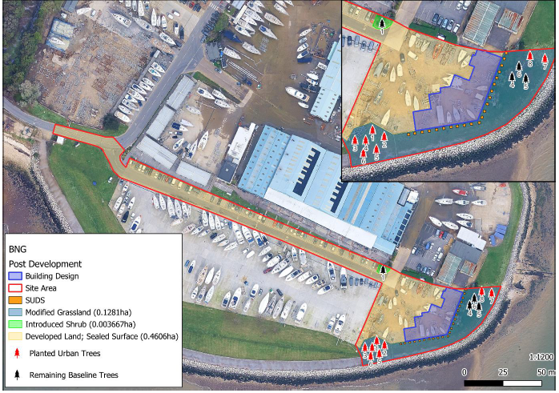

Creation, Enhancement and Management Targets and Prescriptions

Individual Trees

Creation, Enhancement and Management Summary (CS-T01)
Provide details of the approach to delivering each of the targeted condition criteria and habitat. Conditions from Statutory Biodiversity Metric habitat condition assessment sheets – Sheet 9 Individual Trees.
For each condition criteria row, delete the condition targets that aren’t being targeted as necessary.
Limitations (if applicable) |  | Habitat parcel reference
Limitations (if applicable) |  | Grid reference
Condition Assessment Criteria
 |  | Criterion passed (Yes or No) |  |  |  |  |  |  |  |  |  | Notes (such as justification)
A | The tree is a native species (or at least 70% within the block are native species).
B | The tree canopy is predominantly continuous, with gaps in canopy cover making up <10% of total area and no individual gap being >5 m wide (individual trees automatically pass this criterion).
C | The tree is mature (or more than 50% within the block are mature)¹.
D | There is little or no evidence of an adverse impact on tree health by human activities (such as vandalism, herbicide or detrimental agricultural activity). And there is no current regular pruning regime, so the trees retain >75% of expected canopy for their age range and height.
E | Natural ecological niches for vertebrates and invertebrates are present, such as presence of deadwood, cavities, ivy or loose bark.
F | More than 20% of the tree canopy area is oversailing vegetation beneath.

Additional Management Prescriptions (CS-B01)
The habitat creation and enhancement will take place during the project construction and will be complete when the project is finished. There will be no delay in habitat unit creation. Monitoring will initially take place annually in August for the first 5 years, reducing to every 5 years for the remainder of the 35-year monitoring period. Monitoring reports will be submitted every 5 years.
Undertake quadrat photos sampling for canopy cover and in-situ surveys to identify the habitat type that is establishing and then number of species per m².
To ensure good establishment of planting, maintenance should be undertaken for 5 years from Practical Completion (first year to be carried out by the installing contractor). Weed control, watering and replacement of failures in the next planting season.

Please use this space to detail any additional management measures to be conducted along with the above measures. These may for example include (but are not limited to) measures specifically relating to the presence of protected species or may be additional measures that are in support of local nature recovery targets and, or, planning policy.

Individual Trees

Creation, Enhancement and Management Methods (CS-T02)
Provide detailed prescriptions for the creation and management of the habitat.
Action | Relevant parcels | Timing | Prescriptions
Undertake quadrat photos sampling to identify canopy cover %. | 1 | There will be some delay to habitat maturity. Monitoring will initially take place annually in August for the first 5 years, reducing to every 5 years for the remainder of the 35-year monitoring period. Monitoring reports will be submitted every 5 years. | The habitat creation and enhancement will take place during the project construction and will be complete when the project is finished. There will be no delay in habitat unit creation. Monitoring will initially take place annually in August for the first 5 years, reducing to every 5 years for the remainder of the 35-year monitoring period. Monitoring reports will be submitted every 5 years. To ensure good establishment of planting, maintenance should be undertaken for 5 years from Practical Completion (first year to be carried out by the installing contractor). Weed control, watering and replacement of failures in the next planting season.
Visual survey to assess natural ecological niches on trees, maturity, health, native species % and using botanical species list to check against target species list. | 1 | There will be some delay to habitat maturity. Monitoring will initially take place annually in August for the first 5 years, reducing to every 5 years for the remainder of the 35-year monitoring period. Monitoring reports will be submitted every 5 years. | The habitat creation and enhancement will take place during the project construction and will be complete when the project is finished. There will be no delay in habitat unit creation. Monitoring will initially take place annually in August for the first 5 years, reducing to every 5 years for the remainder of the 35-year monitoring period. Monitoring reports will be submitted every 5 years. To ensure good establishment of planting, maintenance should be undertaken for 5 years from Practical Completion (first year to be carried out by the installing contractor). Weed control, watering and replacement of failures in the next planting season.
Undertake regular annual pruning and maintenance to ensure they do not develop into shrubby thickets. Timing of maintenance will depend on species of tree. E.g. Deciduous trees-late autumn-early spring. Stone Fruits- June-August. Birch,Maple,Walnut-Summer or mid-winter. Evergreens-late spring or early summer. | 1 | There will be some delay to habitat maturity. Monitoring will initially take place annually in August for the first 5 years, reducing to every 5 years for the remainder of the 35-year monitoring period. Monitoring reports will be submitted every 5 years. | The habitat creation and enhancement will take place during the project construction and will be complete when the project is finished. There will be no delay in habitat unit creation. Monitoring will initially take place annually in August for the first 5 years, reducing to every 5 years for the remainder of the 35-year monitoring period. Monitoring reports will be submitted every 5 years. To ensure good establishment of planting, maintenance should be undertaken for 5 years from Practical Completion (first year to be carried out by the installing contractor). Weed control, watering and replacement of failures in the next planting season.

Species Lists (CS-T03)
Provide a detailed species list for the habitat to be created
Common Name | Scientific Name | Abundance / % | Comments
Sea Buckthorn | Hippophae rhamnoides | 6
Field Maple | Acer campestre | 4
Midland Hawthorn | Crataegus monogyna | 6
Scots Pine | Pinus sylvestris | 3
Goat willow | Salix caprea | 7
Whitebeam | Sobus aria | 8

Other Supporting Information
Supporting Information (CS-B02)
Please use this space to provide any additional information where relevant.

What Does Success Look Like? (CS-F01)
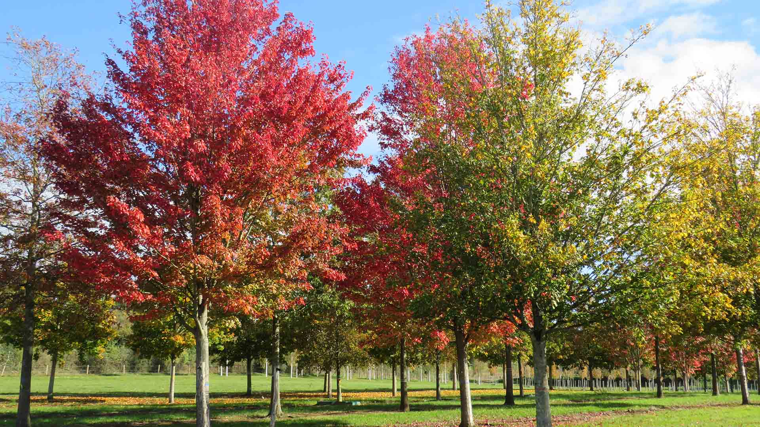
Figure 1.Image Reference: https://trees.hillier.co.uk/about-us/blog/the-best-trees-for-car-parks/

Urban SuDS

Creation, Enhancement and Management Summary (SC-T01)
Provide details of the approach to delivering each of the targeted condition criteria and habitat. Conditions from Statutory Biodiversity Metric habitat condition assessment sheets – Sheet 22. Urban.
A | Vegetation structure is varied, providing opportunities for vertebrates and invertebrates to live, eat and breed. A single structural habitat component or vegetation type does not account for more than 80% of the total habitat area.
B | The habitat parcel contains different plant species that are beneficial for wildlife, for example flowering species providing nectar sources for a range of invertebrates at different times of year.
C | Invasive non-native plant species (listed on Schedule 9 of WCA¹) and others which are to the detriment of native wildlife (using professional judgement)² cover less than 5% of the total vegetated area³.  Note - to achieve Good condition, this criterion must be satisfied by a complete absence of invasive non-native species (rather than <5% cover).

Additional Criteria - must be assessed for Bioswale and SuDS habitat types only:
E1 | Plant species are mostly native. If non-native species are present, they should not be detrimental to the habitat or native wildlife⁴.
E2 | The vegetation is comprised of plant species suited to wetland or riparian situations.

Additional Management Prescriptions (SC-B01)
The habitat creation and enhancement will take place during the project construction and will be complete when the project is finished. There will be no delay in habitat unit creation. Monitoring will initially take place annually in August for the first 5 years, reducing to every 5 years for the remainder of the 35-year monitoring period. Monitoring reports will be submitted every 5 years.
Undertake quadrat photos sampling to identify the habitat type that is establishing and then number of species per m^{2.}
To ensure good establishment of planting, maintenance should be undertaken for 5 years from Practical Completion (first year to be carried out by the installing contractor). Weed control, watering and replacement of failures in the next planting season.

Please use this space to detail any additional management measures to be conducted along with the above measures. These may for example include (but are not limited to) measures specifically relating to the presence of protected species or may be additional measures that are in support of local nature recovery targets and, or, planning policy.

Urban SuDS

Creation, Enhancement and Management Detailed Methods (SC-T02)
Provide detailed prescriptions for the creation and management of the habitat.
Action | Relevant parcels | Timing | Prescriptions
Undertake quadrat photos sampling to identify the habitat type that is establishing against target species list and then number of species per m² | 1 | There will be no delay in habitat unit creation. Monitoring will initially take place annually in August for the first 5 years, reducing to every 5 years for the remainder of the 35-year monitoring period. Monitoring reports will be submitted every 5 years. | The habitat creation and enhancement will take place during the project construction and will be complete when the project is finished. There will be no delay in habitat unit creation. Monitoring will initially take place annually in August for the first 5 years, reducing to every 5 years for the remainder of the 35-year monitoring period. Monitoring reports will be submitted every 5 years. To ensure good establishment of planting, maintenance should be undertaken for 5 years from Practical Completion (first year to be carried out by the installing contractor). Weed control, watering and replacement of failures in the next planting season.

SuDS Species Lists (SC-T03)
Provide a detailed species list for the habitat to be created.
Common Name | Scientific Name | Abundance / % | Comments
False Goatsbeard/False Spirea | Astilbe ‘Fanal’ | 5 n.o 3sq/m | SuDS planters to contain a Mix of the below species with climbers planted against walls.
Tufted Hairgrass | Deschampsia cespitosa | 6 n.o 3sq/m
Red Bistort ‘Superba’ | Persicaria bistorta ‘superba’ | 5 n.o 3sq/m
Snow Rush | Luzula nivea | 5 n.o 3sq/m
Meadow Cranesbill | Geranium pratense | 5 n.o 3sq/m
Guelder Rose | Vibumum opulus | 5 n.o 3sq/m
Daylily ‘Stella de Oro’ | Hermerocallis ‘Stella de Oro’’ | 5 n.o 3sq/m
Pendulous Sedge | Carex Pendula | 6 n.o 3sq/m
Climbing Hydrangea | Hydrangea anommala subsp. Petiolaris | 2 n.o counted
Hall’s Japanese Honeysuckle | Lonicera Halliana | 2 n.o counted

Other Supporting Information
Supporting Information (SC-B02)
Please use this space to provide any additional information where relevant.

What Does Success Look Like? (SC-F01)
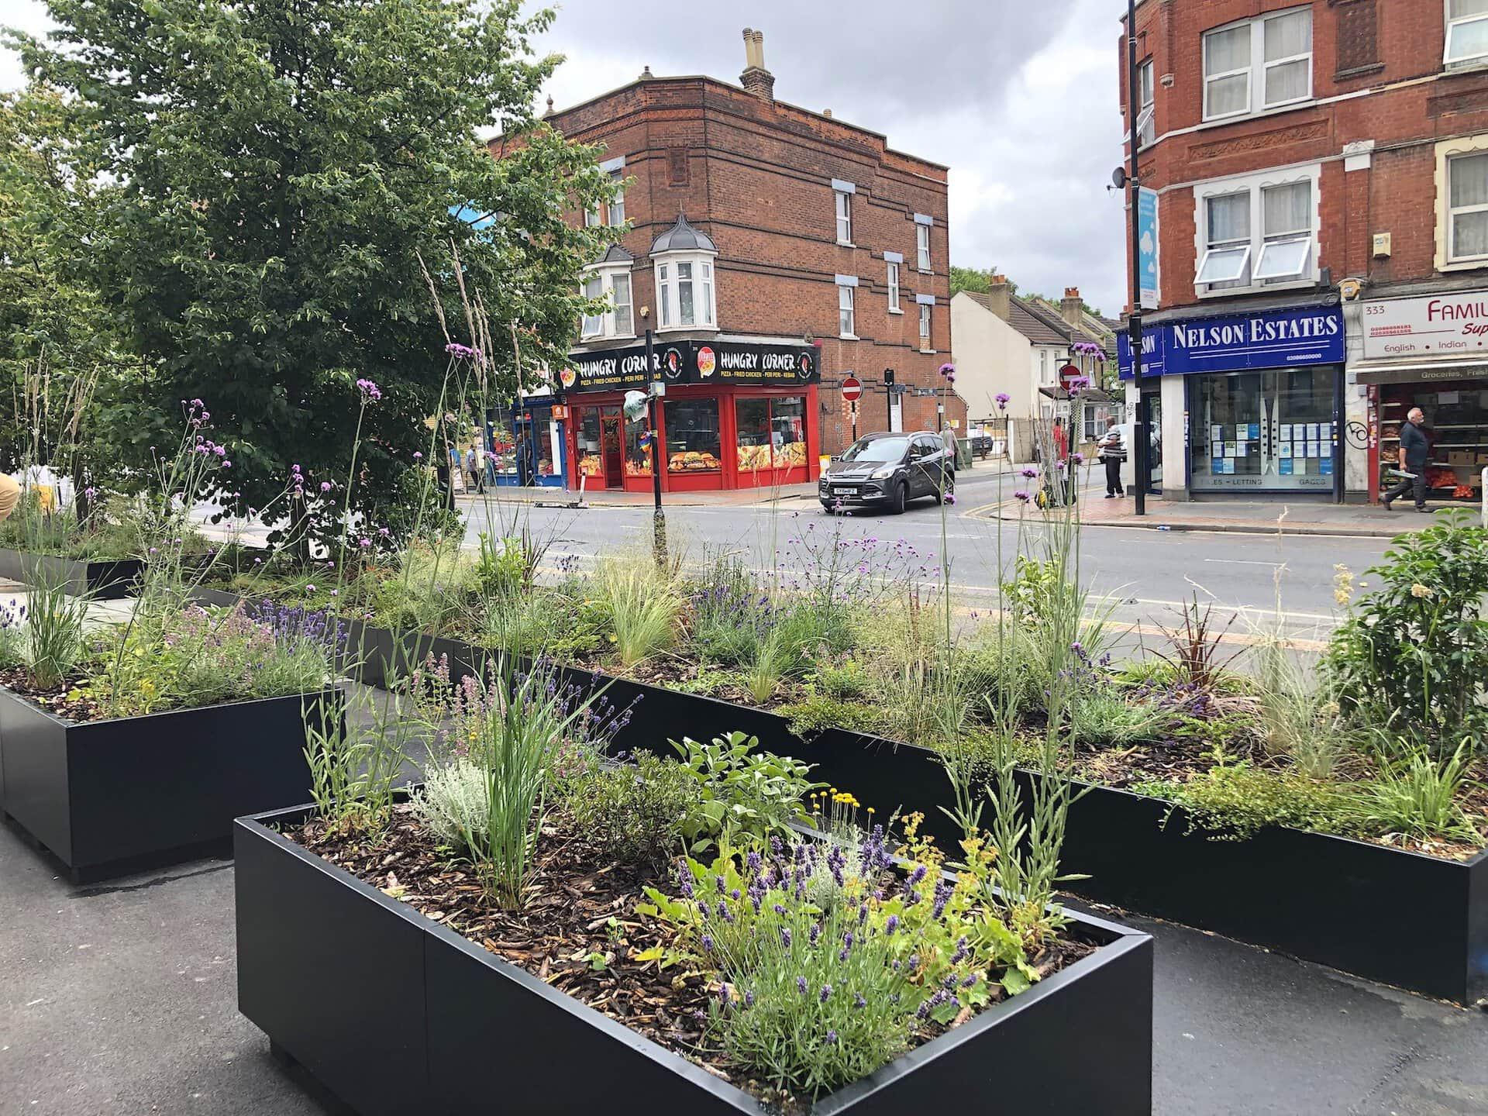
Figure 2. Image reference: https://www.meristemdesign.co.uk/blog/hybrid-suds-planters-an-innovative-solution-for-shallow-dig-rain-gardens/

Templates are available for Area Habitats, Hedgerows and Watercourses
See the HMMPT companion document pages 21-125 for the habitat creation, enhancement and management targets and prescription templates. The Companion Document contains a template for each habitat condition criteria as provided in the statutory biodiversity metric tool and Condition Assessments.
Use these templates to set out the creation, enhancement and management targets and prescriptions for each habitat on your site.
- Plan(s) page
Page 22 includes a blank template for including a plan showing the locations of the habitat creation, enhancement and management measures to be delivered by the HMMP. You can either present a single site-wide masterplan showing the locations of all habitats to be delivered and, or, you can provide individual plans for each of the habitats to be delivered, showing only the locations of the relevant habitats. Use your professional judgement to determine whether individual plans for each habitat are required.

- Tabulated Templates
For each habitat type provided as part of your proposals, copy and paste the relevant templates from the Companion Document into this section of the HMMPT. Use your professional judgement on how to include these. You can

  - include a single table for each different habitat type to be delivered by stating which parcels each criterion is relevant to

and, or

  - use multiple versions of the same habitat template. This may be more useful if you are targeting different conditions in different parts of the site or if differing baseline conditions across your site may affect the management of certain parcels. You can provide a separate set of tables for each different condition requirement of the same habitat by re-copying the same blank template into the HMMPT.

Delete the blue text on this page before copying across sections from the Companion Document.

Habitat Creation and Management – Risk Register and Remedial Measures PM-T02
Provide a site-wide risk register associated with creating, enhancing and, or, managing each habitat type. Consider your approach to delivering the BNG targets in case the management prescriptions do not deliver as expected.
This is a pre-emptive list. The list of potential risks should be as comprehensive as possible to provide confidence in the delivery of the management plan objectives. Complete each habitat's management targets and prescriptions first, then consider the likelihood of the risk occurring and what impacts it may have if it was to occur. Consider how these may feed back into monitoring requirements.
Risk Identification Date | Habitat Type | Risk Factor | Trigger for Action | Remedial Measure
Example: 16-08-2023 | Woodland | Newly planted trees failing to establish | 10% of targeted number of newly planted trees found to be dead during years 1-10. | Plant a larger number of trees initially as contingency against some losses in the early years. Undertake a second round of planting, replacing failed specimens on a like-for-like basis
05-01-2026 | Urban Trees | Newly planted species failing to establish. | Newly planted species found to be dead during monitoring period, with low percentage cover after 5 years. E.g. less than 10%. | Replanting of target species.
05-01-2026 | SUDS | Damage to species in planters. E.g. trampling, clearing, litter etc. | Monitoring shows damage, death and increased prevalence of INNS. | De-risk by ensuring these areas are identified and known to land manager to avoid changes to habitat. Any cleared areas must be re-established. Replanting of target species.

Monitoring Schedule
To deliver BNG, a robust strategy is critical to monitor successes and challenges. Routine monitoring informs progress and facilitates the required management plan updates at set intervals.

Monitoring Strategy
Provide details of the monitoring strategy to encourage successful implementation of the management plan (MS-B01)
The habitat creation and enhancement will take place during the project construction and will be complete when the project is finished. There will be no delay in habitat unit creation. Monitoring will initially take place annually in August for the first 5 years, reducing to every 5 years for the remainder of the 35-year monitoring period. Monitoring reports will be submitted every 5 years.

Provide details of methods that will be used to compare the baseline habitat with the proposed retention, creation or enhancement measures. For example, this may include before-and-after photos, before-and-after surveys and species lists, etc.

Monitoring Methods and Intervals MS-T01
Provide details of the methods you will use to adequately monitor the progress towards the targets stated in the management plan and as agreed with the Local Planning Authority.
Monitoring methods and frequency need to be considered according to habitat type. The text below is only for illustrative purposes. Plan according to your own project and habitat requirements.
Habitat Type | Monitoring Methods | Monitoring Interval and Timing
Individual Trees | Habitat parcels: 1  Undertake quadrat photos sampling to identify the canopy cover %  Collect a botanical species list to check against target species list.  Visual assessment survey to check for ecological niches on trees, maturity, health, native species %. | Annually from years 1-5, then every 5 years.  Surveys to be completed in August.
Urban SuDS | Habitat parcels: 1  Undertake quadrat photos sampling to identify the habitat type that is establishing and then number of species per m².  Estimate percentage of bare ground, bramble and bracken cover.  Collect a botanical species list to check against target species list. | Annually from years 1-5, then every 5 years.  Surveys to be completed in August

Monitoring Reports
Following completion of habitat creation and initial enhancement works, prepare for your monitoring report for the Local Planning Authority or Responsible Body. You should monitor each habitat type comprising the BNG project. Provide sufficient detail for the reviewing authority to assess the progress. The ‘Monitoring Report Template’ can help you do this. The requirements and regularity with which the monitoring reports are required are at the discretion of the LPA or Responsible Body. Prepare the monitoring requirements below.

Monitoring Report Schedule MS-T02
Provide details of the person or organisation that will be responsible for submitting the monitoring reports. Also state the responsible organisation for receiving and reviewing the reports.
Organisation Responsible for Submitting the Monitoring Reports | Organisation Receiving and Responsible for Reviewing Reports
MDL Marinas | Hampshire County Council (Eastleigh Borough Council)

Provide details of when the monitoring surveys and reports will be undertaken and submitted. You can extend the table and adjust according to your required schedule.
Project Year | Month Report to be Submitted | Month Management Plan to be reviewed | Comments
Y1 | September | September or October | Report and evidence photos on results of initial individual trees and Urban SuDS.
Y5 | September | September or October | Summary of annual monitoring surveys and evidence photos conducted every year in the first 5 years. Description of remedial works if necessary.
Y10 | September | September or October | Summary of 5-year monitoring surveys and evidence photos. Description of remedial works if necessary.
Y30 | September | September or October | Summary of 5-year monitoring surveys and evidence photos. Description of remedial works if necessary.
Y35 | September | September or October | Summary of 5-year monitoring surveys and evidence photos. Description of remedial works if necessary.

Adaptive Management
Summary of Adaptive Management Approaches (MS-B02)
The annual August monitoring in the first 5 years will identify any issues at the most delicate early stage of establishing the individual trees and urban SuDS. Once complete, monitoring will take place at years 1,5,10,30,35 until year 35. During the monitoring, actions will be suggested to maintain or improve the condition as required. This will allow for any changes, or degradation to be identified, managed and remedied.
Degradation to any enhanced, created or retained habitat will create actions for reaching the target condition, or even be used as an opportunity to improve condition.
All remedial actions will be described in the monitoring reporting summaries which will be sent to the LPA. Any comments or recommendations can be implemented when these are reviewed.

Use this box to summarise how you plan to incorporate adaptive management. Consider the risks in section PM-T02 above. The aim is to have a feedback loop between monitoring, then reporting, and how any proposed changes are subsequently reflected in this plan.

Adaptive management is a systematic approach to natural resource management that involves monitoring and evaluating the effectiveness of management actions then adjusting as necessary to improve outcomes over time. It is an iterative process in which management actions are followed by targeted monitoring outcomes. These, in turn, inform the ongoing management.

Monitoring results inform necessary management changes to promote achieving BNG targets stated in the statutory biodiversity metric and HMMP. The monitoring can pick up any unexpected, external influences. Some examples are dealing with a new plant disease, an invasive species that is thriving due to climate change, or changes to site access due to site flooding.

Observations and notes from day-to-day management are important for delivering adaptive management. Consider how this information will be captured and fed into changes in management prescriptions, then through to subsequent monitoring reports.

Regular robust monitoring, and reporting to the responsible authority, should identify issues early on. Then you can make conscious decisions to implement effective actions. If the BNG objectives are affected by external factors, it is important to agree decisions on changes to the management prescriptions and targets with the responsible authority. Following the review, record any changes in this management plan and schedule.

