21 Stirling Crescent
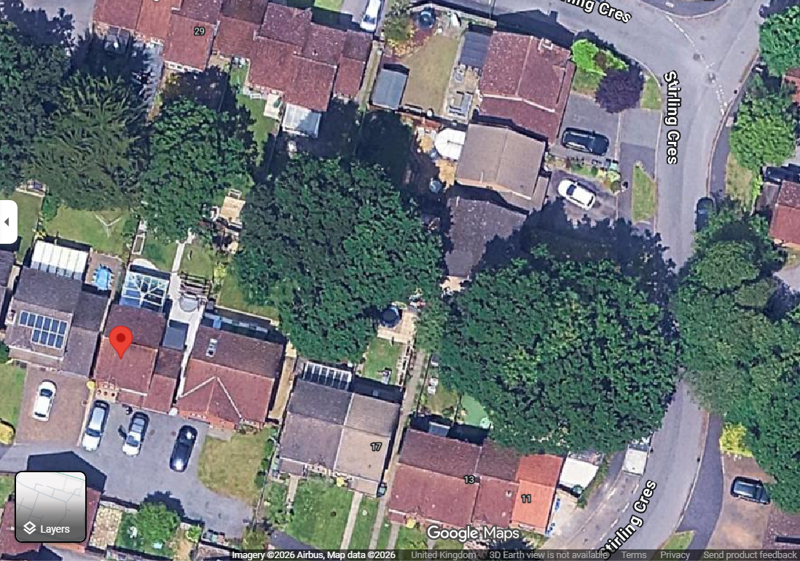
T2 & T3
T1

