Formal Objection to Planning Application F/26/100809
Attention of Case Officer Gary Osmond
Application Number F/26/100809
Applicant c/o Macra Ltd
Site address The Orchard, 5 Westgate Mews, Kenilworth Gardens, Southampton, SO3 3RE.
We wish to formally object to the planned development on the grounds of significant transport and access issues and public safety.
In particular we are concerned that the submitted Transport statement contains several inaccuracies and misleading statements supported by outdated photographs which risk misrepresenting the true impact of the proposed development to the Planning Committee Listed below are the false and misleading statements and more recent images to assist.
1 Conflict with Local Planning Policy
Policy DM13 of the General Development Criteria for Transport (paragraph 5.91) states that new development must:
- Be accessed safely, and
- Wherever possible, be accessible by means of transport other than the private car.
The proposed development does not comply with this policy. There is no safe or continuous pedestrian or cycle access to the site via Westgate Mews. The public footway ends at Kenilworth Gardens, beyond which Westgate Mews becomes a private access drive with no pedestrian provision. As a result, all residents of the proposed eight new dwellings and the existing five properties would be compelled to rely on private vehicles for all journeys, contrary to sustainable transport objectives.
2 Transport Statement Inaccuracies
a) Road Width Measurements (Paragraphs 2.21 and 3.21)
Paragraphs 2.21 and 3.21 of the Transport Statement state that the access road to the site is 4.3m wide. This is incorrect and misleading.
- The entrance to Westgate Mews, marked by the termination of the footway on Kenilworth Gardens and a dropped kerb, measures only 3.7 metres in width.
- The access road briefly widens to approximately 4.7 metres, before narrowing again to around 4.3 metres at the site entrance.
As all vehicles must pass through the 3.7m-wide entrance, this constraint governs access. These dimensions do not safely accommodate two-way vehicle movements, nor do they provide adequate protection for pedestrians or cyclists.

b) Pedestrian Access (Paragraph 2.5.1)
Paragraph 2.5.1 refers to “full pedestrian access.” This statement is inaccurate.
- Pedestrian access exists only along Kenilworth Gardens.
- There is no pedestrian footway within Westgate Mews, which is the sole access route to the proposed development.
This is already an issue for existing residents and would be significantly worsened by the increase in vehicular movements associated with nine dwellings. The Transport Statement itself acknowledges in paragraph 2.5.2 that approximately 80% of journeys under one mile are made on foot, yet the proposal fails to provide safe conditions for walking if using Westgate Mews as the access point to the site.
The absence of pedestrian infrastructure is particularly concerning during the construction phase, when heavy goods vehicles would be using the access. The proposal also fails to consider the needs of disabled, elderly, or mobility-impaired residents.
3. Use of Outdated or Misleading Evidence
- Image 2.2 appears to have been taken over 12 months ago and does not reflect current conditions. It omits vehicles regularly parked in allocated driveways and does not show the narrow 3.7m entrance to Westgate Mews. The image also clearly demonstrates the absence of any pedestrian walkway within Westgate Mews.
- Image 2.1 shows oak trees on the south-east boundary adjoining Utilita Bowl 3 which have since been removed by the owners. We can find no record of local residents being notified of an application or consent for the removal of these trees. We request clarification on when and under what authority these trees were removed, particularly as Oaks are protected.
We have attached updated photographs to assist.
4. Additional Errors
Paragraph 2.31 refers to carriageway characteristics of St Peters Crescent. This appears to be an error, as the description more appropriately relates to Kenilworth Gardens. This further undermines confidence in the accuracy of the Transport Statement.
5. Conclusion
Given the inaccuracies in the Transport Statement, the lack of safe pedestrian and cycle access, the constrained access geometry, and the resulting risks to public safety, we consider that the proposal fails to comply with Policy DM13 and should not be supported in its current form without an alternative access point being proposed.
We respectfully request that the Planning Authority give these concerns due weight when determining the application.

Updated Images
Kenilworth Gardens pedestrian access on only one side and cars regularly parked up on the pavement
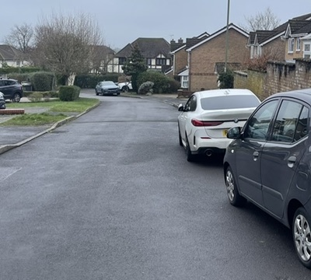
Westgate Mews Entrance over a pedestrian walkway with a dropped kerb of only 3.7m flanked by walls
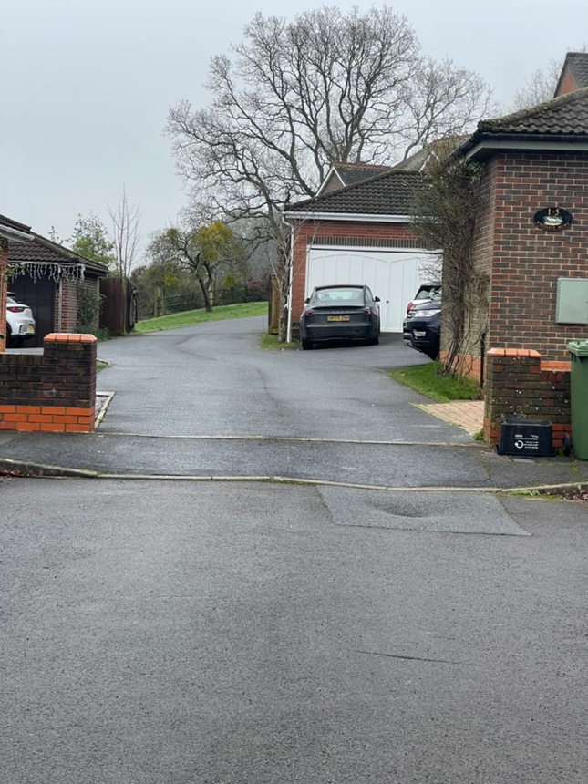

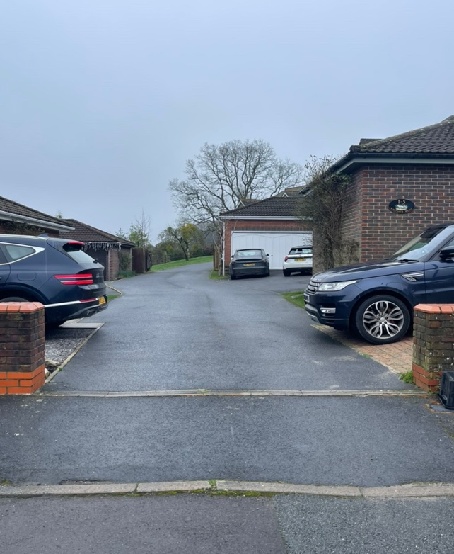
Demonstration that only single lane at entrance and exit of westgate mews and no pedestrian walkway for entirety
