To: Gary Osmond, Case Officer, Eastleigh Borough Council.
Planning Application Ref : F/26/100809
Site Address: The Orchard, 5 Westgate Mews, Kenilworth Gardens, Southampton, SO30 3RE.
Proposal Construction of 8No. detached dwellings with associated amenity space, parking and landscaping.

15th February 2026

Subject: Formal Objection.

I write to formally object to the proposed development at 5 Westgate Mews. For the following reasons.

Kenilworth Gardens has approximately 35 dwellings, consisting of the following.

Fielders Court, senior independent living accommodation which has limited car parking for its Residents, care workers/visitors who often park in the road which reduces the width of both the road and the pavement for pedestrians, and people with pushchairs forcing them to walk in the road.

Sportsman Place- comprising of 8 units which has limited parking for both Residents and visitor, again forcing car users to park in the road.
Leigh side residential home for younger adults with learning disability /autism, although they don’t drive, the required daily carers/visitors have too park in the road due to limited parking facilities.

Access / egress to the 3 private drives within Kenilworth Gardens itself can be problematic due to parked cars in the road often causing a blind spot when entering or exiting the driveway.

Westgate Mews does not have any pavements so pedestrians have no choice but to walk in the road. And as there are no street lights in Westgate Mews this is very dangerous at night.

Utilita Bowl - On match / event days visitors will often park in Kenilworth Gardens, on double yellow lines even when traffic cones have been put out, which are often ignored or moved.

The Grass verge on the entrance into Kenilworth Gardens is constantly being churned up, as delivery lorries are unable to get pass due to parked cars in the road. This often includes the weekly household waste collection vehicles., and the multitude of daily home delivery vehicles, and I am guilty of using a home delivery service. On occasions the grass verge on a neighbouring property also gets driven over, due to a narrowing of the access. see pictures below regarding the grass verge.

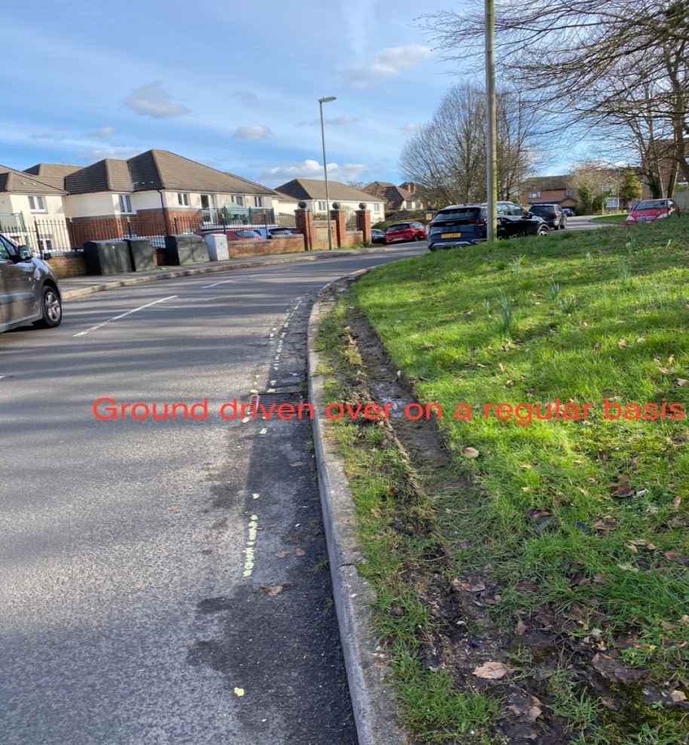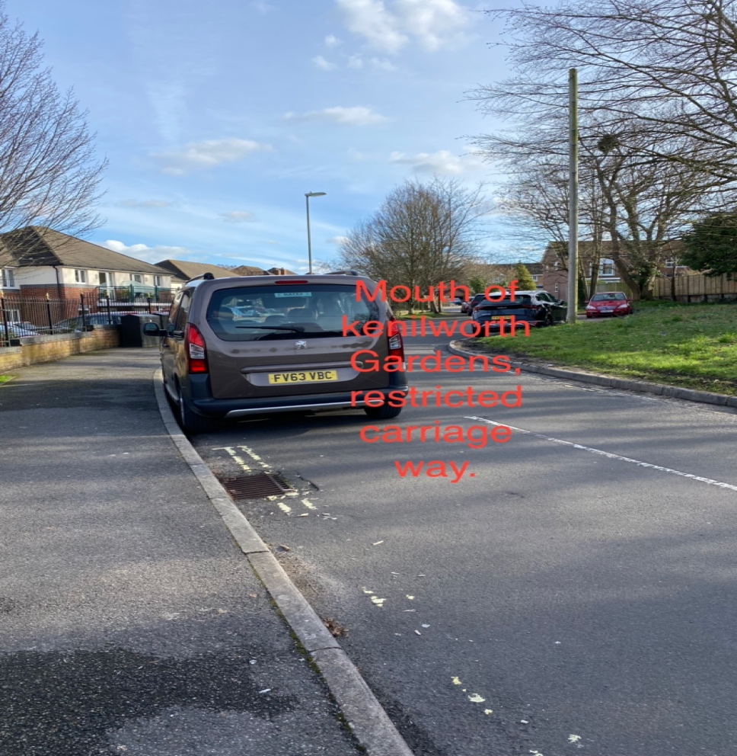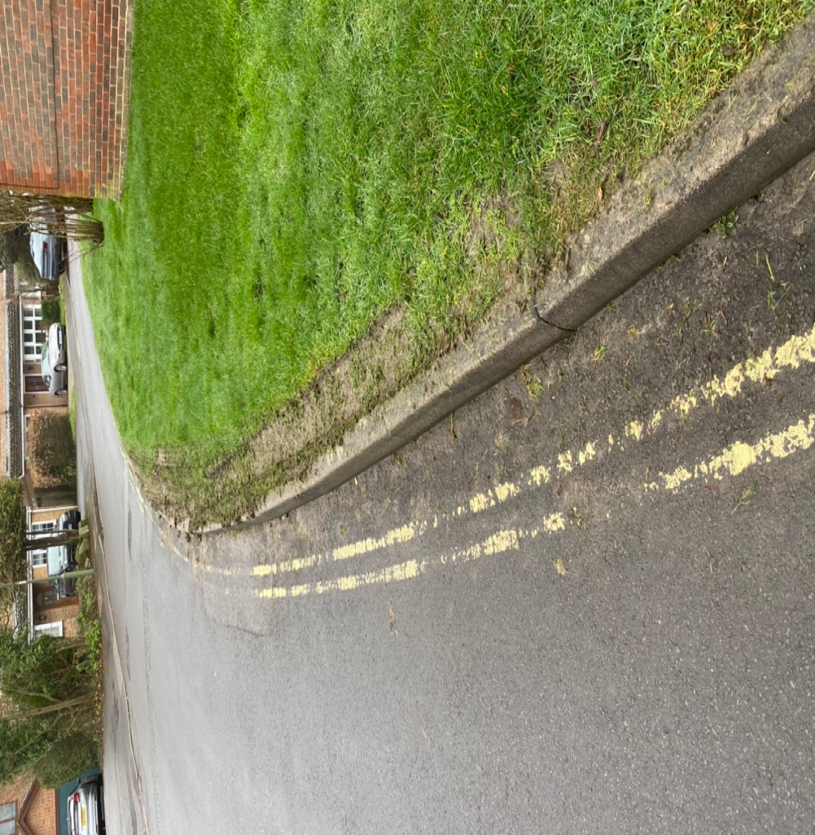

in general, there is not enough parking facilities in Kenilworth Gardens for the Residents let alone visitors, parking for residents has always been an issue in Kenilworth Gardens as most properties only have parking for 2 cars, which means visitors must park in the road.
Kenilworth Gardens is congested on most days due to cars being parked in the road.

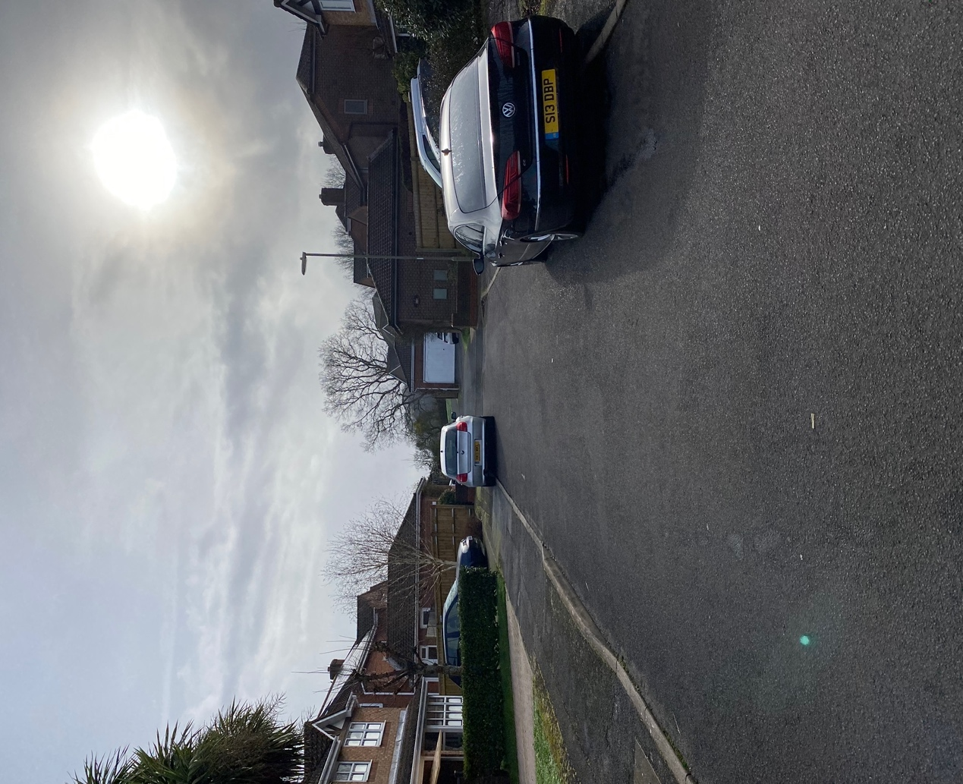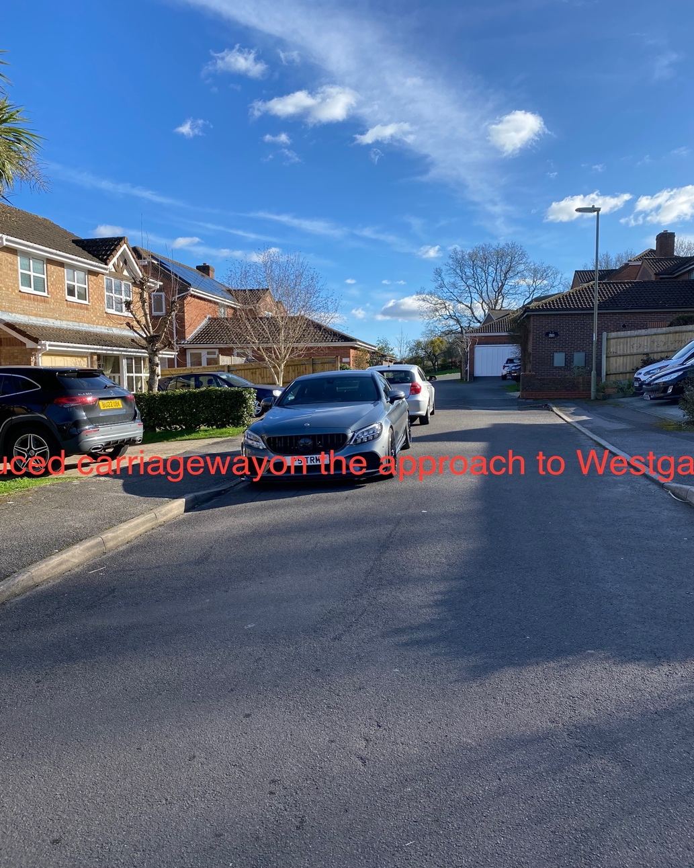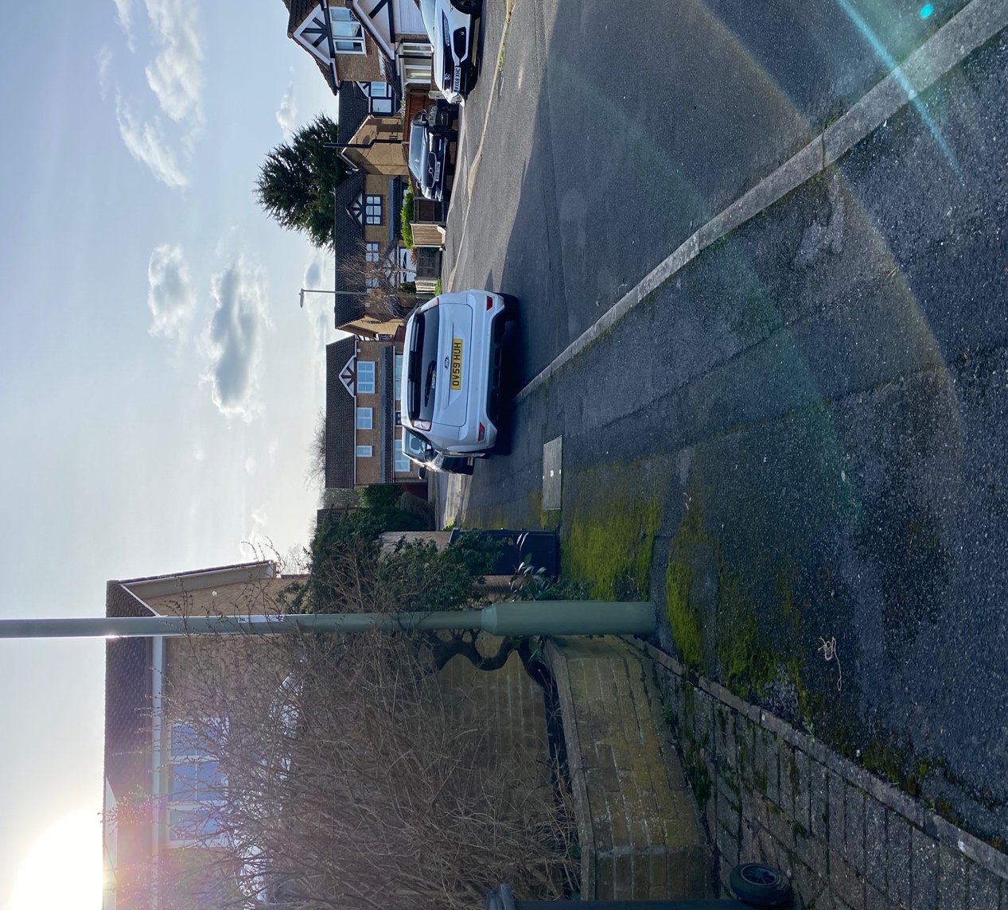

Any increase in traffic will cause further congestion & frustration for the Kenilworth Residents.

Regarding the proposed design of the new development the houses are not in keeping with the current designs of Kenilworth Gardens.

Mrs B McNamara.

